Bible Month June 2020: Ruth

Week One: Ruth 1 An Imaginative Contemplation
You will need: Two or more translations of Ruth 1
Pray: focus your mind and ask God to open up the passage to you and teach you new things.
Divide: split into three groups, and designate each of the groups as either Ruth, Naomi or Orpah. The next three steps (Read, Imagine, Discuss) should be done in these smaller groups.
Read: go through Ruth chapter 1 twice – you might want to read two different translations, for example New International Version and either The Message or Passion.
Imagine: sit quietly for a moment and close your eyes, picturing the scene and everything about it. Put yourself in the shoes of your character. You may find it helpful to go through each of your five senses and think about what you can see, smell, touch, hear and taste as your character.
Share: get the three groups to come back together and share what they’ve learnt/discussed from imagining themselves as a different character within the story.
Pray: pray that just as this scene has come to life today, you might also become more aware of God’s presence in every aspect of your life.
Discuss: use these questions as a guide, your conversations and creativity may take you somewhere else and that’s OK.
a. What’s your role within the story/scene?
b. How do you feel?
c. Is there anything unique that you learn from this perspective?
d. What might reflecting on Jesus’ character say about this person’s situation?

Week Two: Ruth 2
Approaching the text from the point of view of a migrant
Read: Ruth chapter 2.
Reflect: so what’s the story? Retell the story as if Ruth writes it. From your personal experience, read ‘into’ or ‘between’ the text. Using your own experience to read ‘what is not said’ in the text is one of the main aspects of a feminist approach to reading the Bible.
Relevance: think about Ruth as a migrant or seasonal worker in the UK today. What would be her needs and fears? How might the local church support and welcome her?
Share ideas about what your churches are already doing to welcome and support outsiders.

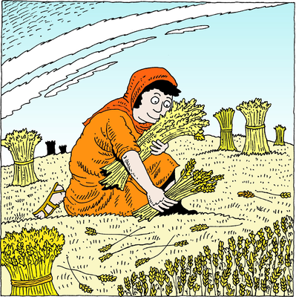

Week Three: Ruth 3 Reading Ruth Through a Postcolonial Lens
You will need: pens & paper
Read: chapter 3 and familiarise yourself with the text
Explore the world of the text: identify the characters and their role in the text. Choose the character (Ruth, Naomi or Boaz) that you identify with most and explain why?
As this particular character, do you have power in the story? Why do you behave the way you do?
Write a ‘postcard’ from one character to another, dated perhaps ten years after the end of the story in chapter 4. Read out the postcards and look for the different voices and types of relationships that are revealed. Discuss your discoveries in groups.
Explore the world in front of the text: how might your sociopolitical, cultural and religious experience influence the way you respond to the story? How does the postcolonial reading of Ruth challenge you in your context? Think about how your faith might help you resist.

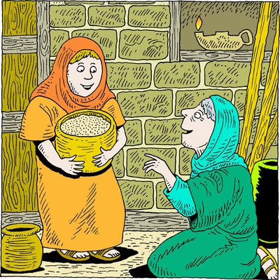

Week Four: Ruth 4 Reflecting on Our Story With Others
Prepare: read Ruth chapter 4 together; you might find it helpful to read a number of different translations.
Pair: split everybody into pairs to discuss the following questions:
• How do Ruth and Naomi support one another throughout the book
• What stands out to you from chapter 4 and why?
• The book of Ruth points us to Jesus – where is God at work in your life right now?
• If your life were a story split into four chapters, which chapter would you be in and why?
• Who do you have alongside you in your present chapter? How might you and them work together and support one another?
Share: draw everyone back together to share their reflections in the larger group.
Prayer: if able, get everybody to stand in a circle facing the same direction with their hands on the shoulders of the person standing in front of them, so everybody is connected. Explain that everybody is going to pray out loud simultaneously for the person whose shoulders they’re touching. This can be anything from something the person has shared, to a general prayer, to simply repeating ‘God bless you.’ Count to three upon which everybody should begin praying for one another.
