Lent 2022 Pledge for the Planet- Green your garden!

Lent 2022 Pledge for the Planet
The members of the Circuit Eco Group will share some of their thoughts over the next 6 weeks. Many of them have made a 'pledge for the planet'; taking a particular area of their lives and make it more sustainable. They will share their highs and lows and hopefully encourage you to make a few simple changes in your household too. Maybe you could make one change this Lent..?

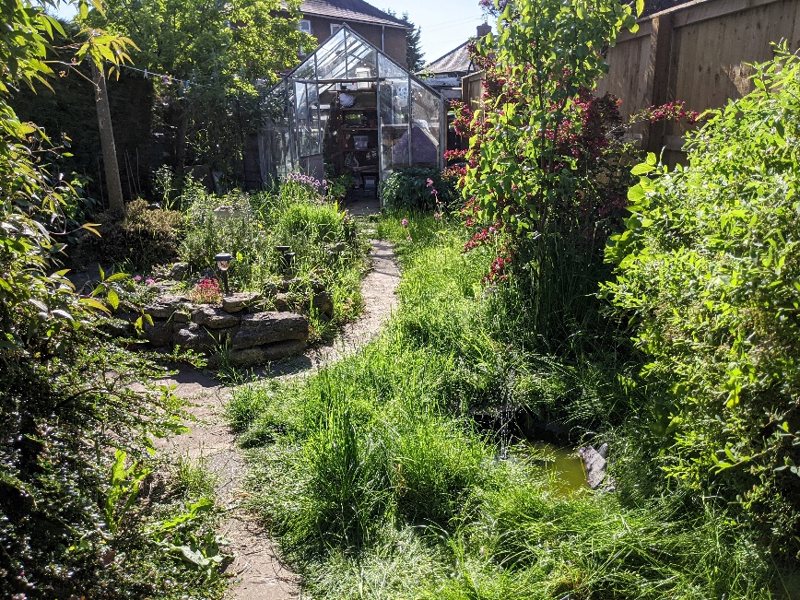

At this time of year many of us are thinking about our gardens and making plans about what to grow in the coming months. My garden is quite small but there are still things I’m doing to try to make a positive impact on the environment.

The good news is that making our gardens better for the planet can be as easy as doing nothing! Leaving grass to grow a bit longer and not being too quick to tidy up dead leaves or logs can help make your garden more inviting for wildlife. It does require being willing to accept that your garden won’t be neat and tidy- I find it’s a good excuse for being a bit lazy! If you prefer a tidier garden, maybe start by just leaving a small area unmown- leave the grass to grow until at least June to give insects and other small creatures a boost. If you can, even leaving a few stinging nettles in a corner can provide a home for certain caterpillars that need them to feed on- meaning you should get to see more butterflies. Insects might seem a pain when they’re buzzing around your picnic, but without them plants don’t get pollinated and birds and other creatures go hungry, so if you can avoid using pesticides that kill off insects please do. If you can plant some wildflowers too both you and the insects will enjoy the blooms!

I didn’t have much luck with my bird boxes or bug hotel last year but I’ve already seen bluetits investigating the nesting box this spring so I’m hoping to see chicks! Last year I made a small pond. I was a bit sceptical at first but the birds love it, and hopefully other wildlife will also find it in time. I also have a birdbath and bird feeders positioned so I can watch the birds while I’m doing the washing up, which makes it less of a chore.

On the subject of water, droughts are likely to become an increasing issue for gardeners with hotter summers and more uncertain weather. I have one water butt and am hoping to install more. You can also reduce the need for watering by grouping containers together (to reduce evaporation) and using bigger containers (that can store more water in the soil)- you could put them on wheeled stands to make it easier to move them around.

Many people are now aware of the devastation and habitat loss caused by digging up peat, which has been a major ingredient in compost you buy from the shops. Peat is also a carbon store, so digging it up only makes the climate crisis worse. Many peat-free composts are now widely available, but sometimes it’s not obvious if the compost contains peat or not, so it’s worth checking. I’ve been trying to use only peat free compost for the last few years, but it was only last year that someone pointed out that it was worth checking that plants bought from garden centres or shops have been grown in peat free compost too.

My garden isn’t perfect, and there will always be more to do. But it’s good to know I am doing something to make a difference, even in a small way.

For more ideas on making a nature-friendly garden, have a look at https://www.rspb.org.uk/get-involved/activities/nature-on-your-doorstep/

Prayer
Creator God, we thank you for growing things, and all that makes our world beautiful. Give us your wisdom to be good stewards of your world and to care for all the plants and creatures that make up our habitat, both locally and globally. Amen.

