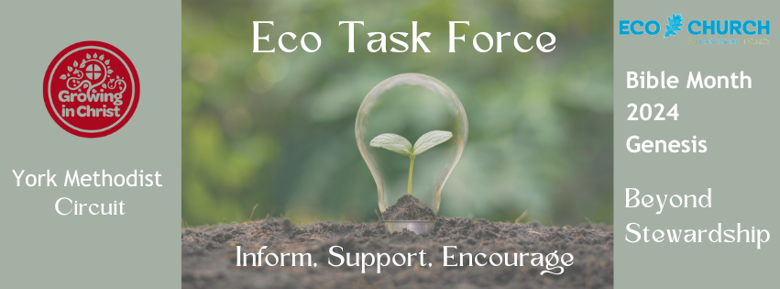
Eco Church Order of Service for Bible Month 2024
Genesis: Beyond Stewardship

Welcome:
Opening prayer: Canticle of the Creatures by St Francis of Assisi
Song: https://www.youtube.com/watch?v=dLMVqNwypjA Indescribable Chris Tomlin
Reading 1: Genesis ch1 v26-28 (on screen) NRSV version
Reading 2: Genesis ch 1 v26-28 (on screen) the Message version
Introduction to the diagrams showing our relationship with nature:
Video of Wood wide Web (incorporated into the powerpoint)
https://www.youtube.com/watch?v=yWOqeyPIVRo
Reflection: Beyond Stewardship
Questions for discussion (see separate sheet)
Prayer: Create a paperchain prayer. Give a few options to pray for:
What has made you think?
What are you thankful for?
What do you feel hopeful for?
When they have finished they should link them together on their tables with glue dots. They then link to other tables. Have it connecting the tables together if possible. (but collect them up before people start to move around!)
Bring together with a prayer: Tearfund hope for creation prayer or other
https://www.youtube.com/watch?v=_qZ-Nw6C46M teach me to dance Graham Kendrick
Blessing:
https://www.youtube.com/watch?v=uZ55mDL7dA0
Kari Jobe and Cody Carnes

