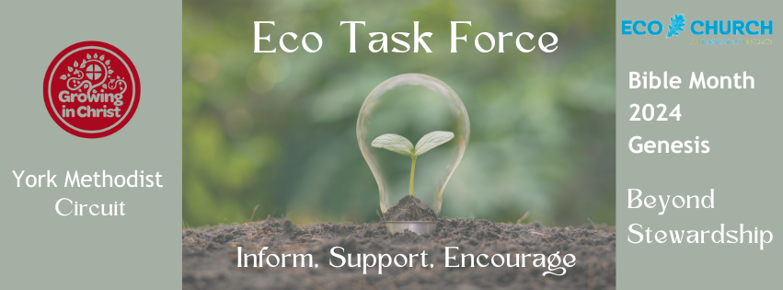

Introducing the diagram – how we view nature.

I want to introduce you to a helpful way of thinking about our relationship with nature. They are two very different world views and we might recognise them in different cultures.
On the left is a traditional, Western view of our place in nature. You see the man at the top, then a woman, then mammals all the way down to microscopic cells and bugs. Even our view of stewardship has this hierarchy in mind when you think back to that first reading. The second diagram is a much more reciprocal, interconnected view of our relationship with nature. We are more likely to see this in more Eastern and indigenous world views.
The thing is, even in an increasingly secular society, the hierarchical way of thinking is ingrained in our culture. There is still that unspoken hierarchy and view of nature. We see this in many ways in our society; think of how we export our waste to poorer countries, extractive industries, misogyny, racism, so many other issues. There is definitely a hierarchy there – what or who is considered ‘important’.
Scientists are increasingly discovering how interconnected we are and how essential all nature is to each other. Impact on one part of the system will eventually have an impact on all the other parts.
(Show video of the wood wide web).

