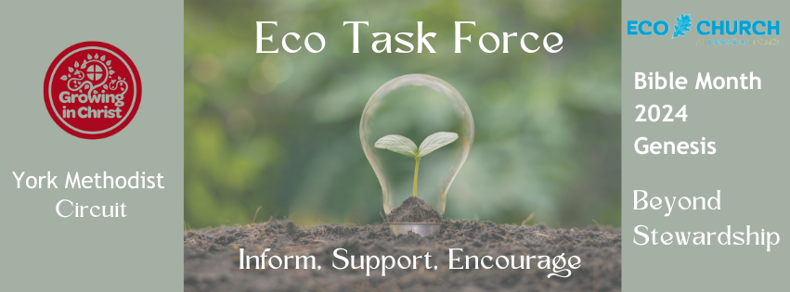
Bible Month – Genesis 1, Our relationship with the environment
Jen Horne
The limitations of Stewardship.
Generally speaking, I’m really pro-stewardship. Being good stewards is exactly what we should be doing with our time…with our talents…with our relationships. So, where’s the problem? Perhaps we could rectify a lot of our troubles with ideas of stewardship with one simple change. We should stop thinking in capital letters. Whether we mean to or not, stewardship often becomes capitalised. It is a role we take on. To Steward the Earth. To be A Steward of Resources. To place ourselves back at the top of that pyramid of creation. Yes, the Genesis story of creation does have God placing humans “in charge” – having “dominion over” the rest of creation. But the bible doesn’t stop at Genesis 1.
I’ve been thinking a lot recently about the first being last and the last being first. That’s part of Jesus’ flipping of the world order. At several points through the gospels, Jesus makes us aware of this idea. Those of us who think that we are top of the pile will find ourselves nearer the bottom. If we think we should always come first, we won’t find ourselves in that position for long. In Mark chapter 9, Jesus tells his disciples clearly, “Anyone who wants to be first must be the very last, and the servant of all”. Imagine the picture of a banquet, with the expectation that the most important seats are up near the head of the table, sitting right next to God. Consider, in Jesus’ world order, who will fill those spots? When I hear of injustices on the news, my prayer for those people involved is that they find themselves one day sitting at the head of the table, right there with Jesus and that he looks them in the eye and says “I know. And I’m sorry. Eat with me now and be healed.”
So, what does this have to do with Stewardship? Well, I also think about the story of Adam naming all the animals in Genesis. In children’s bibles, the illustrations show us Lions and Eagles and Whales…what did Adam name last? Was it a worm? Or a flea? Or a dung beetle? When we put ourselves at the top of creation and view stewardship as something with a capital letter, something we do to nature rather than with or for the world, who or what are we putting at the bottom of that hierarchy? Sometimes it is the aspects of creation that we don’t even pause to think about, like our freedom to breathe clean air, like the work of the worms under the ground, tidying up and making new. Sometimes, in our efforts to control and use the earth’s resources, it is our fellow humans, our brothers and sisters, who we prioritise so little as to put them at the bottom of that pyramid. “Come to the head of the table,” says Jesus to those our stewardship has neglected. “Take this seat next to me.”
So, what can stewardship look like, what could we change in our view of creation that moves us from a capital-letter stewardship to a connection with creation that is less hierarchical, more relational and, simply, better?
First, I’d like to suggest we find some joy! What a glorious world we live in. I love seagulls. They are so ridiculous. Have you ever watched a seagull walking on the beach…and running away from the waves?! As if they are scared to get their toes wet…as if they are playing a game most of us will have played at some point in our lives. God didn’t need to create seagulls. Certainly, God did not need to create seagulls that make us laugh.
Have you ever walked through the woods, sat on a park bench or opened your window at home and heard the riot of birdsong available for our joy? I’m sure there are ways creation could have been “simpler” – God could have made less types of birds, less birdsong, less beauty. But here we have it all. Take the joy!
There’s more…a full spectrum of colours in a flower bed – or perhaps just one perfect tulip; watching a caterpillar do its thing, slow across a pavement; the intricacy on a snail shell…whatever it is about creation that lights you up, let it. Celebrate it, revel in it, be delighted.
And when we have found some joy in the world around us? What next?
Perhaps we need to ditch the word “resource” – and especially resource management. When we talk about the world mainly in terms of resources, we put ourselves back at the top of the pile again. Yes, there are lots of wonderful things in the world that we can use for incredible purposes – and many that we genuinely need. But what if we start thinking of them as gifts, not resources? Might that change the way we use them and share them?
Another way to think about our actions with regard to the environment is “what’s the most loving thing I could do?” Another Jesus-idea we can layer over the original instruction to Adam to have “dominion over” creation is love. These don’t have to be big changes, big decisions, just simply, when you have a choice to make – perhaps in the supermarket over which product you buy; or in your garden, what do you choose to plant; or where you buy your clothes from – is there a more loving choice available to you? We can’t make perfect decisions in such a complicated world but we can, to the best of our knowledge and abilities, make the most Jesus-like choices by considering the most loving way we can act.
It's also important to acknowledge that we all have different areas of interest and passion – and these are God-given. Not all of us are motivated by the actual environment. Some of us are motivated to act on behalf of refugees. Or access to education. Or healthcare. It’s really important that we recognise these are all part of the interconnected injustices in our world, and part of the climate crisis, and wherever you feel called or motivated, acting in that area will also have a positive impact in the others. Don’t fight against who you are, fight with it!

