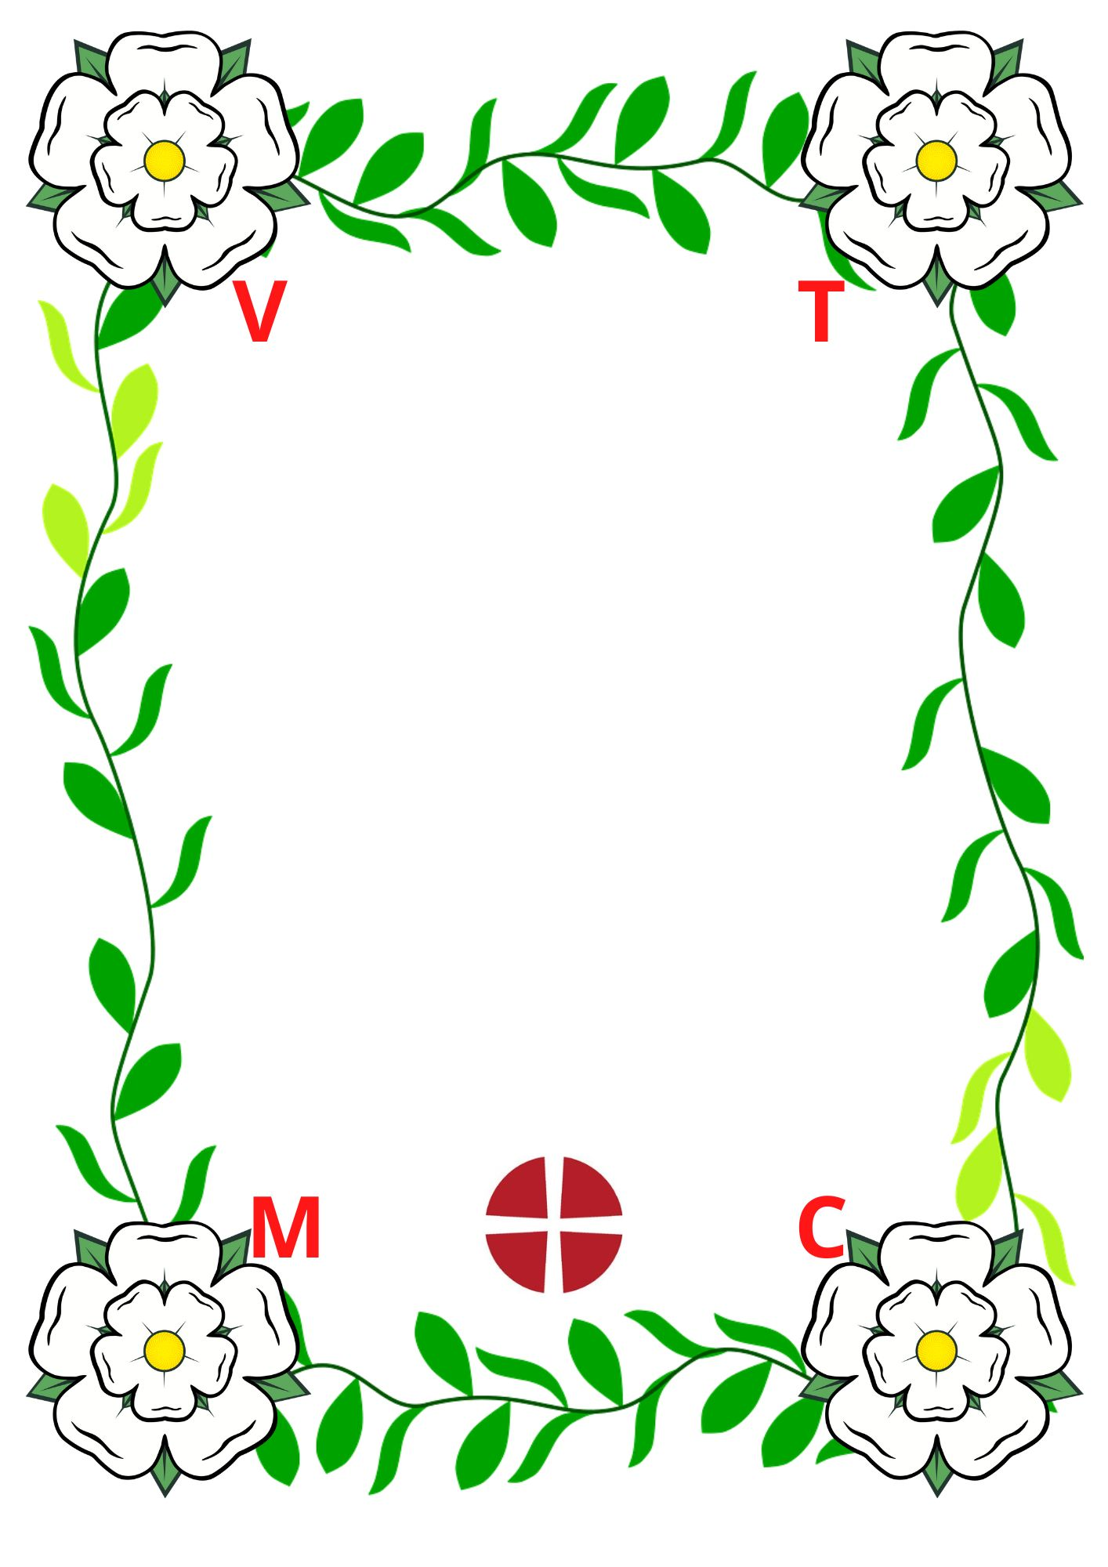
Villages Together
Methodist Church

Stalls, Books, Jigsaws,
Bacon Butties,
Coffee, Tea, Cake..
Huby Chapel
Sat 28 February
10am - Noon
We look forward
to seeing you there.

