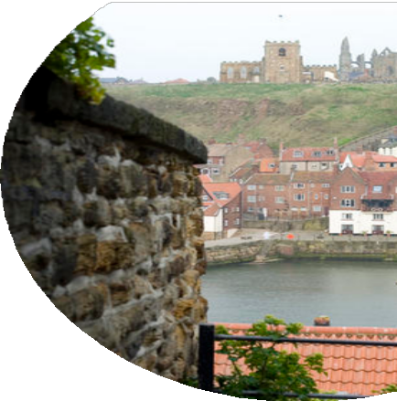
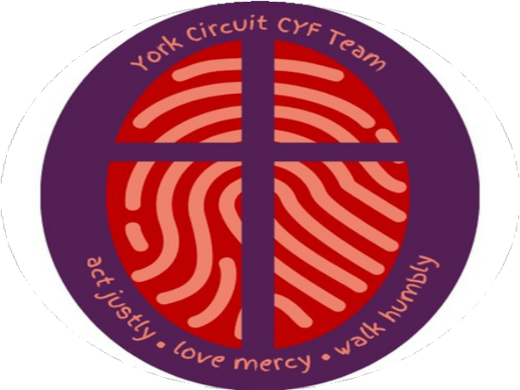

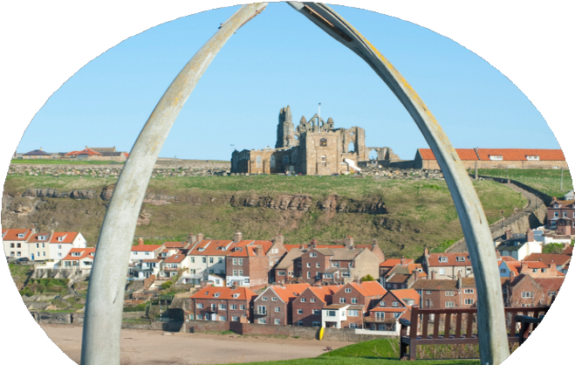
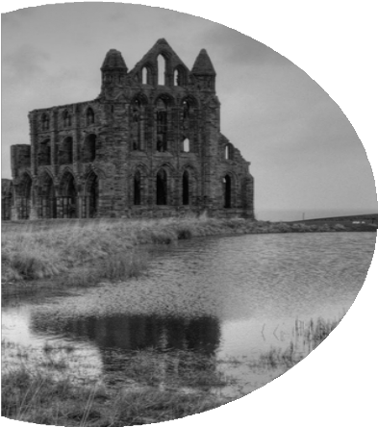
WHITBY

29 JULY
ONEX
Summer Trip

FREE!
Leaving the Circuit Hub at 9am returning at 5pm
Unaccompanied young people must be year 6 and above.
Accompanied younger children welcome
For more information or to book contact Victoria 07473 065856 victoria@methodistyouth.org.uk

