


Bible Month June 2018: Jonah

This booklet supplements the materials provided by the Methodist Church in the Bible Month magazine on Jonah.
This can be downloaded from: http://www.methodist.org.uk/our-faith/the-bible/bible-month/bible-month-magazine/
The Bible Month magazine also contains material for small groups, and suggests different methods of studying the text.
We recommend that you read the whole book of Jonah before starting. You may find it helpful to read it in different translations- the website www.biblegateway.com will allow you to read many different translations.
The suggested format for the group studies is
- Opening activity
- Discussion based on the passage, using the questions given here or the activities in the Bible Month magazine.
- Reflection
- Prayer
We’ve also given suggested times in brackets for each section. You don’t have to stick to these but do try to leave time for prayer and reflection as it can easily get squeezed out. Feel free to either focus on a few of the questions that interest your group or to follow up questions and discussions that interest you.

Groups will need someone or a team to plan the sessions, facilitate the discussions and ensure that appropriate resources are provided.

Week One Jonah 1: The God who Pursues
You will need: Bibles

Starter: Have you ever been asked to do something you didn’t want to do? How did you react? (15 minutes)

Read: Jonah chapter 1 (5 minutes)

Discuss: (45 minutes)
1. What surprises or interests you about this passage?
2. Why do you think Jonah is so reluctant to go to Nineveh?
3. How do the sailors react to the storm? How is it different to Jonah’s reaction? Who is more responsive to God?
4. How do you think the sailors felt when Jonah told them he was responsible for the storm? (v7-16)
5. How do you react to God’s call to ‘go’? (see Matthew 28 v19-20) Are you more like Jonah or the sailors?

Reflection: (10 minutes)
Think about different ways God might want to speak to you over the next few weeks. Is there anything you think he is calling you to do?

Prayer: (15 minutes)
- Pray for those who have stepped out in faithfulness to God’s call to go to those who don’t know him- abroad and at home.
- Share any prayer needs and pray for each other.

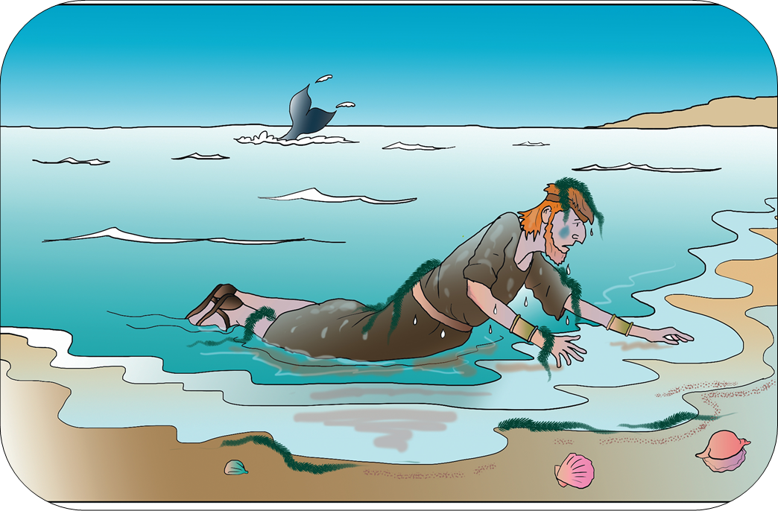
Week Two Jonah 2: Out of the Depths
You will need: Bibles, paper, pens

Starter: Draw a big fish on a sheet of paper. Invite the group to write or draw on it situations of distress or suffering in the world today. (15 minutes)

Read: Jonah chapter 2 (5 minutes)

Discuss: (45 minutes)
1. What surprises or interests you about this passage?
2. How do you think Jonah felt at this point? Does he acknowledge why he’s ended up inside a fish?
3. How does Jonah describe God? What characteristics of God does he see as important?
4. Does Jonah being down in the belly of the fish for three days remind you of anything else in the Bible? (Matthew 12 v40)
5. Has God ever met you in your distress? How did you call out to him?

Reflection: (10 minutes)
This passage takes the form of a psalm. Spend some time writing your own psalm, either a paraphrase of Jonah’s (putting it in your own words) or based on your own experience of calling out to God. You may like to put on some music in the background, such as a setting of Psalm 139 or another psalm.

Prayer: (15 minutes)
- Use your psalms to pray for the situations you identified in the Starter (above) and for each other. Some people might like to read their psalms aloud, others might prefer to meditate on them quietly.
- Share any prayer needs and pray for each other.

Week Three Jonah 3: Mission Accomplished?
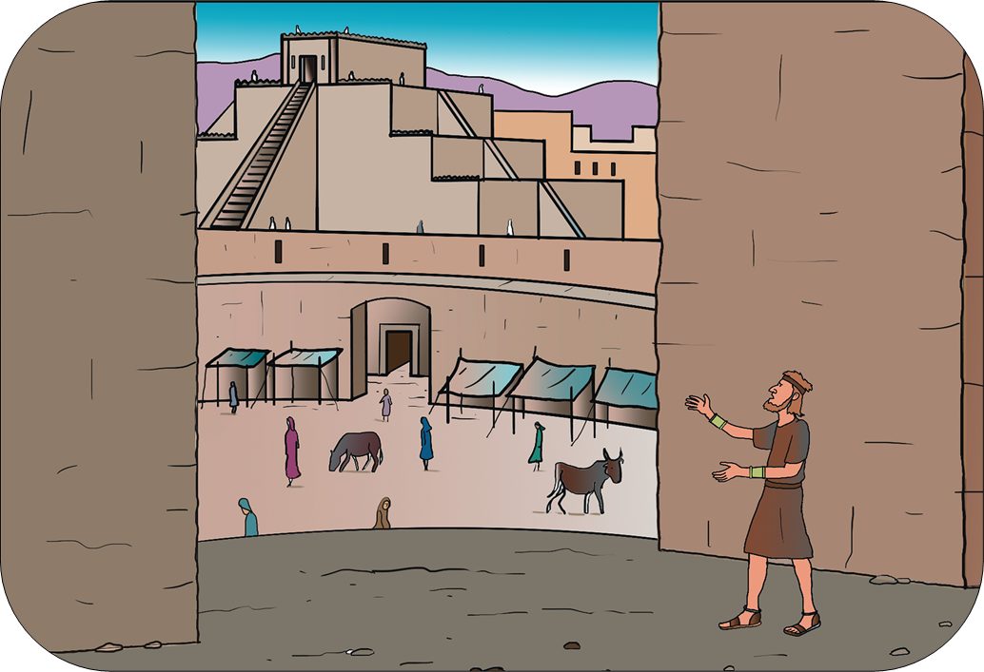
You will need: Bibles

Starter: When have you been really sorry about something you did? What did you do to show you were sorry? (15 minutes)

Read: Jonah 3 (5 minutes)

Discuss: (45 minutes)
1. What surprises or interests you about this passage?
2. How is Jonah’s response in chapter 3 different from his response in chapter 1?
3. What actions did the Ninevites take to show their repentance?
4. How do you think the repentance of the Ninevites might challenge us today?
5. Who are the ‘Ninevites’ today whom God might be calling us to reach?

Reflection: (10 minutes)
How does this passage challenge us in our own life and faith?
How does this passage encourage us in our own life and faith?

Prayer: (15 minutes)
- Pray about any attitudes to God or others you need to be sorry for.
- Pray for those who might be ‘Ninevites’ today and for anything you can do to reach them.
- Share any prayer needs and pray for each other.

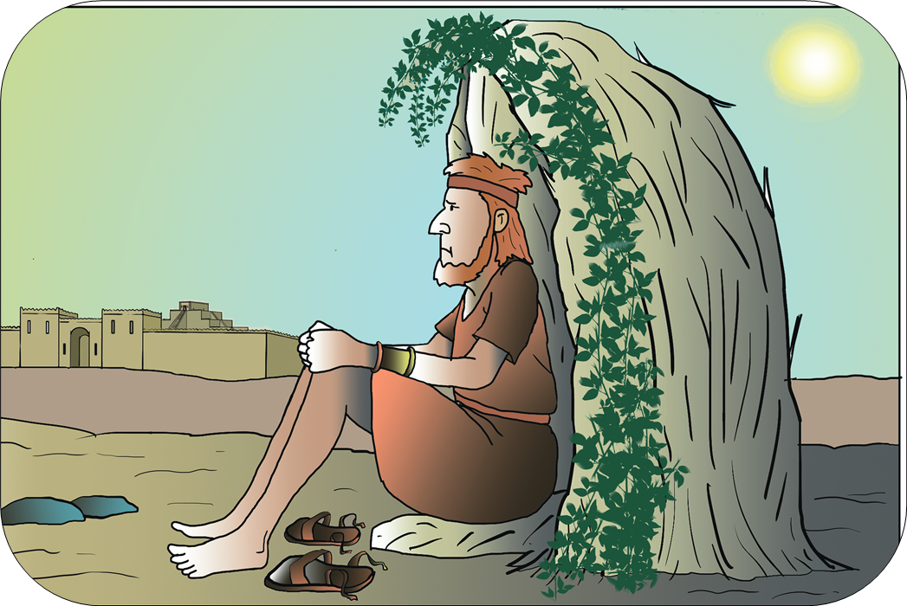
Week Four Jonah 4: A Mixed-Up Missionary
You will need: Bibles, paper leaf shapes (see over the page for a template), pens

Starter: On leaf shapes, write down things that make you angry- anything from your children not listening to you to war and famine. Put the leaves together in the shape of a vine (you’ll use this later on). (15 minutes)
Read: Jonah 4 (5 minutes)

Discuss: (45 minutes)
1. What surprises or interests you about this passage?
2. Why do you think Jonah struggles to accept God’s love for the Ninevites?
3. The worm, the plant and the big fish were all part of God’s plan, while Jonah struggled to accept the role he and the Ninevites played in it. Can you think of any examples of creation serving as a witness to God? (see Luke 19 v37-40, you may also be able to think of experiences in your own life).
4. What can we learn about God from this passage (and the book of Jonah as a whole, see especially chapter 2)?
5. What can we learn about God’s relationship with humanity?

Reflection and Prayer: (15 minutes)
- Look at the things you wrote you were angry about.
- Spend a moment quietly telling God how you feel about these things, and ask him to help you have the right attitude.
- Share any prayer needs and pray for each other.

(Please see over the page.)
Reviewing Bible Month: (10 minutes)
Share together what you have discovered during Bible Month. Write down any insights or actions that you hope to consider further in the coming weeks.
We’d love to hear how you got on. What did you find helpful? What would you like to change if we did Bible Month again?
Pass on any feedback you’d like to share on to the circuit office.

Leaf template to trace or draw round


Supplementary prayers (taken from Roots worship material)

Week One: The God who Pursues
Thank you for the chance to be together as God’s family.
Jesus, we know that, in many parts of the world, people gathered together to worship you;
that, for hundreds of years, people have formed communities in which they can share their love for you;
that, here today, we can all gather to praise and discover more about you.
Thank you for this special place where we meet, for the special people we meet with, for the chance to be together as God’s family.
May this community always be important to us, but may it also be a place we can invite others to, as they find out more about your love.
Amen.

Week Two: Out of the Depths.

A prayer confessing how difficult we often find being a true follower of Jesus.
Lord God, we often say that you love us, that you care for us, and want the best for us.
We say it because we know it is true,
but we can say it so much that we forget how hard it sometimes is to follow your way.

We are sorry for all the times we have not done what the Bible tells us we should do,
because what it asks makes us feel uncomfortable.
We are sorry for all the times we have been scared to say to other people
that we are followers of Jesus,
afraid that we might get bullied or laughed at.
Help us to put you first in our lives,
and not be afraid to let others know we are followers of Jesus.
When following Jesus means doing things we are scared to do,
help us to be brave and do them anyway.
Help us to remember that your love is stronger than anything,
and that you will give us what we really need.
Amen.

Week Three: Mission Accomplished?
Loving God,
fill us with your Holy Spirit.
Give us whole hearts, Lord, so that we may meet other people and recognise your life in them. Make us whole-hearted Christians.
Loving God,
fill us with your Holy Spirit.
Give us your vision, Lord, in everything we think and do. Sharpen our minds so that we see to the heart of things. Help us to understand what you want us to do. Help us to choose your way of life rather than ours.
Loving God,
fill us with your Holy Spirit.
Let us hold fast to our faith, Lord. Draw us to your heart. Teach us to love one another. Make us strong in you.
Loving God,
fill us with your Holy Spirit.
We pray for those in trouble, for the wrongly accused, for the exploited, for people who are treated as less than human. Speak in the hearts of those who damage these people. Restore your creation.
We pray for people who have no centre to their lives, the rootless and homeless – the lost people. Bring them home.
Loving God,
fill us with your Holy Spirit.
We are part of your community of love. We pray for ourselves and our brothers and sisters in Christ, for the whole communion of saints – those who live with you in your marvellous light, for the church throughout the world, and for those who are to come.
Loving God,
fill us with your Holy Spirit.
Amen.

Week Four: A Mixed Up Missionary
A Prayer of Intercession
God of the field and river,
of the desert and oasis,
of the plain and steppe,
of the town and city:
Lord of all,
we ask your blessing.
For people who are waiting for food,
for people who are waiting for water,
for people who are waiting for shelter,
for people working to relieve want and need,
wherever they are, whoever they work with:
Lord of all,
we ask your blessing.
For children and young people,
for their families and friends,
for the old and infirm,
for the childless and the bereaved,
for those working to bring communities together:
God of all,
we ask your blessing.
For each Christian community meeting today,
for our leaders and all committed to their care, for our missionaries, teachers and administrators, our worship leaders and worshippers,
for all those working to forward your kingdom:
God of all,
we ask your blessing on this world.
Amen.

