



Bible Month June 2020
Ruth
Resources for use at home

This year’s Bible Month takes place against the backdrop of the coronavirus pandemic, the shutdown of churches for many weeks and widespread fear and anxiety. As this is being written we don’t yet know if Bible month will be able to happen as planned in services and small groups. Since the resources produced by connexion are written with groups in mind, this resource is an attempt to make the material suitable for use at home.
If you cannot join with others in person, read the passages, think about the questions, and if you are comfortable doing so perhaps chat to friends online or via text about what you have thought. If you’re happy with the technology, you could have a discussion with others via Zoom or another video-conferencing programme; if that’s not your thing maybe set up a text, email or WhatsApp group with friends and send them your thoughts. For some people communicating in writing will be hard, but for others it may be easier than speaking. Using a variety of methods helps us meet everyone’s needs.
If you’d prefer to avoid technology altogether, perhaps you could keep a journal of your journey through Ruth, or express yourself creatively- art, writing, music, or something completely different!
You might choose to use the material once a week, or to revisit it on different days- it’s up to you. You might find that one aspect of the passage sticks in your mind, and you spend all your time considering that- and that’s fine too.

Whatever you do, we’d love to hear about it- if you’re happy to share your experience with the Circuit please get in touch.

Week One: Ruth 1 An Imaginative Contemplation

Pray: focus your mind and ask God to open up the passage to you and teach you new things.
Choose: pick one of the three women in this passage, either Ruth, Naomi or Orpah.
Read: go through Ruth chapter 1 twice – you might want to read two different translations, for example New International Version and either The Message or Passion.
(The website www.biblegateway.com allows you to search the Bible and look at different translations.)
Imagine: sit quietly for a moment and close your eyes, picturing the scene and everything about it. Put yourself in the shoes of your character. You may find it helpful to go through each of your five senses and think about what you can see, smell, touch, hear and taste as your character.
Reflect: use these questions as a guide to reflect. Your mind and creativity may take you somewhere else and that’s OK.
a. What’s your role within the story/scene?
b. How do you feel?
c. Is there anything unique that you learn from this perspective?
d. What might reflecting on Jesus’ character say about this person’s situation?
Repeat: if you have time, or on different days, repeat the exercise with the other characters. Consider what you have learnt from imagining yourself as a different character within the story.
Pray: that just as this scene has come to life today, you might also become more aware of God’s presence in every aspect of your life.
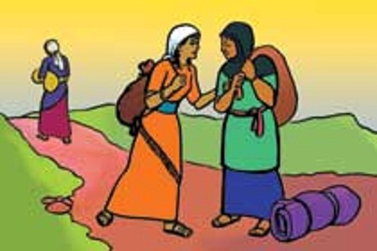

Week Two: Ruth 2
Approaching the text from the point of view of a migrant

Read: Ruth chapter 2.
Reflect: so what’s the story? Retell the story as if Ruth writes it. From your personal experience, read ‘into’ or ‘between’ the text. Using your own experience to read ‘what is not said’ in the text is one of the main aspects of a feminist approach to reading the Bible.
Relevance: think about Ruth as a migrant or seasonal worker in the UK today. What would be her needs and fears? How might the local church support and welcome her?
Consider what your church is already doing to welcome and support outsiders.
Pray: for those who are refugees or migrants who have had to leave family and home to travel to places where they may not be welcome. Pray for those who help them find the help they need and make new homes. Pray especially for the two refugee families living in homes provided by the Circuit.

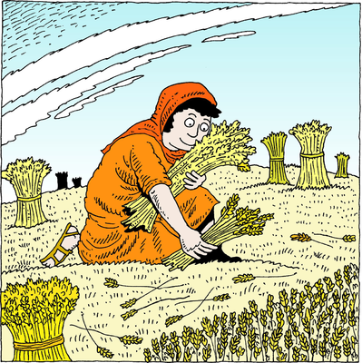

Week Three: Ruth 3 Reading Ruth Through a Postcolonial Lens

Read: chapter 3 and familiarise yourself with the text.
Explore the world of the text: identify the characters and their role in the text. Choose the character (Ruth, Naomi or Boaz) that you identify with most and consider why.
Consider: As this particular character, do you have power in the story? Why do you behave the way you do? What influences your actions? What are you aware of that perhaps other characters aren’t?
Write a ‘postcard’ from one character to another, dated perhaps ten years after the end of the story.
If you can, share the postcard with others, and look at what they have written- you could perhaps do this by email with other members of your congregation. Look for the different voices and types of relationships that are revealed. Reflect on your discoveries.
Explore the world in front of the text: how might your sociopolitical, cultural and religious experience influence the way you respond to the story? How does the postcolonial reading of Ruth challenge you in your context? Think about how your faith might help you resist.
If you’re struggling, perhaps try to imagine a modern equivalent of this story, and how we might feel about people who behaved in this way today.
Pray for those who are poor and marginalised in our society, and for those who are lonely or elderly.

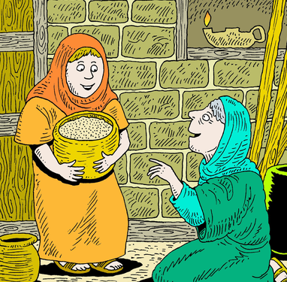

Week Four: Ruth 4 Reflecting on Our Story With Others

Prepare: read Ruth chapter 4; you might find it helpful to read a number of different translations. (The website www.biblegateway.com allows you to search the Bible and look at different translations.)
Consider the following questions:
• How do Ruth and Naomi support one another throughout the book?
• What stands out to you from chapter 4 and why?
• The book of Ruth points us to Jesus – where is God at work in your life right now?
• If your life were a story split into four chapters, which chapter would you be in and why?
• Who do you have alongside you in your present chapter? How might you and them work together and support one another?
Prayer: consider who you have identified as being alongside you. This might be family members, friends, or church members. Consider what their needs are, if you know, and pray for them. You might find it helpful to make a list, and pray for two or three people each day.
If you can, share with those people that you are praying for them.
