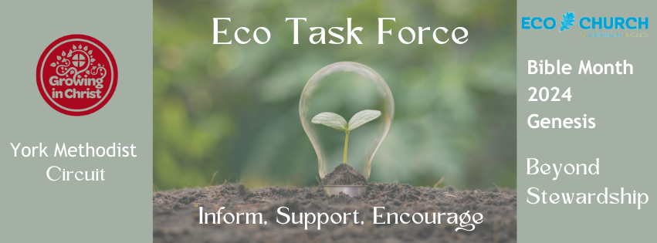
But what next ??! Follow up action
All too often people hear the urgency of the Climate and Biodiversity Crisis, but then feel stumped about what they can actually do about. Surely doing a bit more recycling isn’t the answer?!!! Correct! Action on Climate Change needs to happen on 2 levels. Firstly, the things we can do as individuals to limit our impact and get ready for the change that is to come. What we do also has ripples into our homes, workplaces and communities. It shouldn’t be underestimated, but it isn’t enough.
We also need to work on systemic change – adding our voice to push for change that will have a wide reaching impact. For example, asking for regulations, investment and all sorts of other actions that will shape our economy and society in a more positive way. The good news is that the same systemic changes which are needed to tackle climate change, will usually improve other problems too, like health and poverty.
Here are two suggestions which tackle Climate Change and Care of Creation from both directions.
ACTION 1: The Great Big Green Week 8th-16th June

The focus this year is on making swaps. What are some simple swaps that you could do individually and as a church? If you are feeling like a challenge, host an event such as a uniform, clothing, plant or toy swap. Are there some simple swaps your congregation could commit to as individuals – here’s a few ideas:
- The biggest swap is to change your thinking! The fact is that we are going to have to ditch fossil fuels, and the sooner the better. Instead of thinking about the way the world IS, think about what a post-fossil fuel world might look like in the FUTURE. There would be no plastics available for everyday things like shampoo or sweet wrappers. How might the world work instead? As you go around your house and get on with your life, think about what that might look like without fossil fuels.
- Got an item at home that comes in plastic? Swap it out for one that comes in glass or tin. Eg Fizzy drinks, milk.
- Take small bags to the greengrocer or supermarket to pick up loose products like mushrooms or apples, instead of choosing the ones that are in plastic.
- Swap buying new clothes for second hand as much as you can.
- Try growing your own! Pick something that always comes in plastic and give it go – for example green beans, lettuce or tomatoes.
- When choosing greetings cards – choose ones that don’t come in plastic. Or even send e-cards!
- Here’s a biggy -when your boiler is in it’s last year or two, thinking about switching to a heat pump. Don’t wait until it’s broken in the middle of winter when the easiest thing is just to get another boiler.
- When buying presents, think about swapping ‘stuff’ (which usually comes in plastic!!) for experiences, or ‘promises’ like cooking a meal for someone or babysitting.
- Swap out car use whenever you can. Figure out your local bus services and use those , or walk or cycle.
- Swap out laundry liquid that also comes in plastic to powder or laundry sheets. These usually come in cardboard.
https://greatbiggreenweek.com/take-action/swaps/
This is a great little video introducing it and showing what other folk are doing.
https://www.youtube.com/watch?v=mz0_ZWni7eM

ACTION 2: USE YOUR VOICE – it’s an election year! Help to get the Climate and Nature Bill through Parliament.

The climate and nature bill is supported across political parties by many MPs. Zero Hour is the organisation that has pulled it together and wants to get it through parliament. A few weeks ago they launched a new call to action. 2024 is a critical year since it is a general election year. Whoever is voted in will be critical to the planet and all our futures. Zero Hour have a really effective and simple way to get involved.
Go to this link to put in your postcode to get your constituency. The website will tell you who your candidates are. When you add your name to an open letter it will be added to other signatures. When they get to a critical number, Zero Hour contacts the candidates and explains that the bill has the support of their constituents and asks them to support it. Once they have confirmed their support they get a green tick above their name, so people can go into the voting booth knowing which of the candidates will vote for the bill should they get into power.
https://action.zerohour.uk/
The launch was supported by Deborah Meadon from Dragons Den and Chris Packham. What we need is cross party and wide ranging support for the Bill. It gives us a framework to tackle the climate and nature crisis but also does so in a way that ensures a fair and just transition, so those who can least afford to take action (and usual have done the least to cause the problem) don’t bear the brunt.
You can sign up as individuals (please do!) but you can also sign up as an organisation. Is this something your Church can do?
There is also a video you can share to promote this – based on Monty Python’s ‘Romans’ sketch called ‘Toadwatch: What has nature ever done for us?’
https://www.youtube.com/watch?v=PhlMWK7GysA

