

York Women of Faith

A self-guided trail around historic York following in the footsteps of inspirational women of faith. (approx. 1 hour)
Note: In York, streets are often called ‘Gate’. The term ‘snickleway’ refers to a narrow alley which runs between buildings.

Sister Jean Oglethorpe (1925-1998)
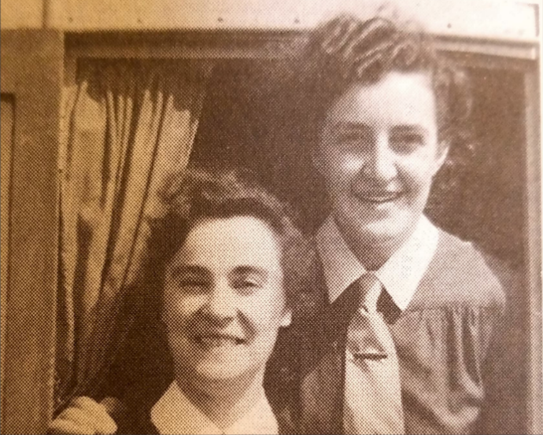
If you look through the railings on the left hand side of Central Methodist Church you see the Carecent building, a Methodist project that has been feeding homeless and vulnerable people in York for 40 years.
Sister Jean, a Methodist deaconess, started her training as a 21 year old and served in Caravan missions before being sent to York in 1960. In 1984 she set up Carecent, a project to serve homeless and vulnerable people at Central. We have lots of first-hand accounts from people who knew her:
Figure 1 Photo (from Saved to Serve by E. Dorothy Graham): Jean (right) with Joan Dickenson (left) while they were serving on Caravan Joy in 1949.
"Having met Jean, one could never forget her! She was a large as life character. Full of vitality and full of smiles. Her face told the picture of her faith.”
“She loved people - and people got that message."
“She had a great sense of humour and apparently thought it hilarious that a farmer, who found her inspirational, named a cow after her!”
She was a keen York City football fan and later in her ministry trained as a Social Worker at Leeds Polytechnic where her tutor commented: “An outstanding degree of commitment, which may best be described as a loving concern. No situation and no person is outside the scope of her wish to give. Fortunately she is also endowed with remarkable stamina to encompass the size of the tasks she sets for herself.”
To learn more about Carecent’s current work https://www.carecent.org.uk/
How do our lives show God’s love extends to everyone and that no one is beyond God’s love?

- As you exit Central, turn left along St Saviourgate. You will see alms-houses (with a coat of arms at high level) on the right and the Unitarian Chapel on your left.

Lady Sarah Hewley (1627-1710)

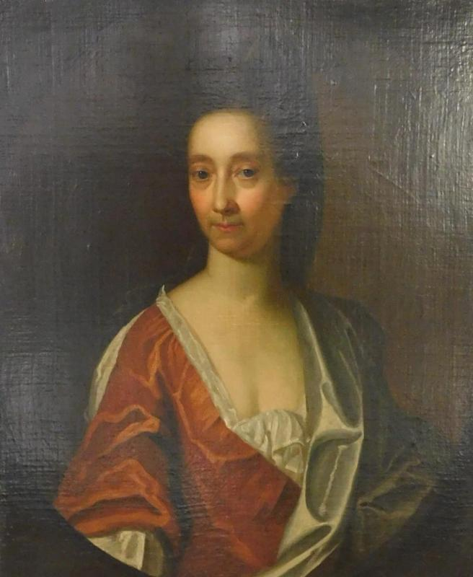
The Hewleys were dissenters and, around 1692, they contributed to the building of the Unitarian chapel in St Saviourgate, the street in which the family lived.
On the death of Lady Sarah’s second husband, she inherited his estate and she financed the construction of a set of houses on Tanner Row to house nine elderly widows of dissenter ministers and a chaplain.
On her death her estate was put into the hands of trustees, but the trust was very wealthy and there was concern that the income was not being distributed fairly. The matter was taken to court in 1830 and, after lengthy legal proceedings, the Charitable Trusts Act 1853 now known as The Charity Commission was set up.
Around 1835 George Hudson, the ‘Railway King’, was granted powers under an act of Parliament to compulsorily purchase the Tanner Row alms-houses in order to build railway tracks through the city walls and construct a railway terminus. A new set of alms-houses was built on St Saviourgate and the occupants from Tanner Row were transferred to the new building, which is still in use to this day.
In spite of Lady Sarah’s Trust being formed more than 300 years ago, it still runs the alms-houses in St Saviourgate which are maintained by a group of trustees who meet regularly to administer the various other charitable works.
To learn more visit https://yorkcivictrust.co.uk/heritage/civic-trust-plaques/lady-sarah-hewley-1627-1710/
What does being trustworthy mean for us in our lives?

- At the end of St Saviourgate turn left, walk along Spen Lane, take the snickleway that runs down the side of St Andrew’s Evangelical church and you will find yourself on St Andrewgate.

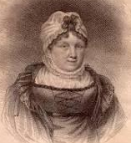
Catharine Cappe (1744 – 1821)

Catharine Cappe was a Unitarian and worked tirelessly for those less fortunate than herself. She put in place organisations that would benefit those living in poverty, particularly girls at risk of being thrown out on the streets and safeguarding the future of women who might find themselves without any security.
Amongst her many initiatives she and Faith Gray set up evening classes so that the workers at a local hemp factory could learn to read, setting up a York School for Spinning Worsted on St Andrewgate. The school was staffed by women volunteers and the girls were taught to read and to spin and in return the students were paid wages for their work and clothed.
She and Faith went on to reform education at the Grey Coat School, a school for poor girls in York which was by then located on Monkgate.
Throughout her life Catharine was interested in improving education and helping others. She was a proponent of women, visiting people in hospitals, medical care for the poor and supported the movement to stop the use of climbing sweep boys. Through her writing on education many of her ideas and practices on educating the poor were spread to a wider audience.
How can we respond well when we see things that are not fair and need to change?

- Cross St Andrewgate onto Bartle Garth bearing right, past Bedern Hall and turn left through the snickleway beside York Glaziers’ Trust on to Goodramgate where you turn left.
- Continue bearing left following Goodramgate until you come to the gates for Holy Trinity Church on the right hand side. They are quite easy to walk past - look out for the Old York Bakery.

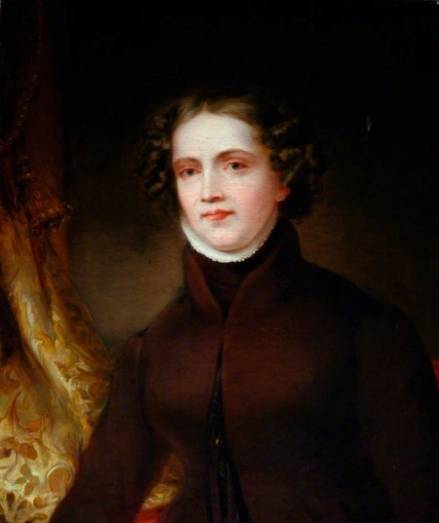

Anne Lister (1791 – 1840)

Anne Lister, an entrepreneur, writer, and traveller took sacrament at Holy Trinity, Goodramgate to seal her union with her female partner Ann Walker in 1834.
Anne defied the social conventions of Victorian England and was excluded by many. You can learn more at: https://yorkcivictrust.co.uk/heritage/civic-trust-plaques/anne-lister-1791-1840/
How do we include those who feel marginalised and celebrate diversity?

- Walk through the grounds of Holy Trinity (if open, if not walk up Goodramgate and turn down right down Low Petergate) and emerge onto Low Petergate. Turn right and walk up Low Petergate until the junction with Stonegate. Turn left down Stonegate and straight on past Betty’s to St Helen’s Square. Ahead of you is Mansion House and the Guildhall.

Edna Annie Crichton (1876-1970)

Edna, a Quaker, stood for election to York City Council in 1919. She was Chairman of the Housing Committee working on slum clearance programmes and visited every family affected by demolition.
During World War II she was elected Lord Mayor, the first woman to be Lord Mayor in more than 700 years!
In the early hours of 29 April 1942 York was bombed. Over 70 people were killed, 190 injured and 9,500 homes destroyed or damaged. The medieval Guildhall was hit by an incendiary bomb and burned for most of the next 24 hours. Lord Mayor Edna Annie Crichton toured the city the next day, speaking to the bereaved and visiting the wounded in hospitals.
Edna always stressed the need for women councillors saying “thoughtful men and women [should] elect a Council representative of all sections of the community.” At her memorial service she was described as ‘a little woman with the heart of a lion’.
To learn more visit https://yorkcivictrust.co.uk/heritage/civic-trust-plaques/edna-annie-crichton1876-1970/

How can we use what influence we have to be kind and compassionate to those who are suffering?

- Turn left and walk down Coney Street until you reach Next on the right hand side.

Henna, wife of Aaron 13th Century

Henna was a Jewish woman and she and her family lived on Coney Street. After her husband Aaron’s death in 1260, she continued to make grants and manage the family business despite increasingly harsh taxation and regulations imposed on Jews by the Crown.
She and her children were assisted by the Jewish community in London which safeguarded not only their home but the synagogue to the rear of the property (now commemorated with a blue plaque).
To learn more about Aaron and Henna and other people who lived in Coney Street visit the University of York’s Streetlife project: https://www.streetlifeyork.uk/projects/jewish-coney-street
In 2023 Rabbi Elishiva Salamo became the first rabbi to live in York since the massacre at Clifford’s Tower over 800 years ago.
How might God be calling us to support those experiencing prejudice and injustice today?

- At the bottom of Coney Street turn right, cross Ouse Bridge, turn right on North Street and continue until you reach All Saints Church.

Mary Breckinridge (1881-1965) and Adeline Cashmore - All Saints Church, North Street

There is a room behind All Saints church, now used to house the heating controls, which is a reconstruction of a cell used by religious recluses in medieval times. In 1924 Adeline Cashmore, while living a life of prayer here, was introduced by her sister to an American student midwife, Mary Breckenridge.
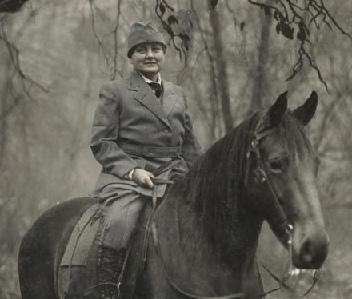
Though they only met again a few times, they wrote to each other and Adeline became Mary’s spiritual guide. Mary had experienced tragedy with the death of her two small children but went on to use her skills and resources to provide for women and children in need. Following her midwifery training in London Mary returned to the USA where she founded The Frontier Nursing Service, the horse-riding nurse midwives serving poor women in rural Kentucky. Before her initiative rural deaths in childbirth were commonplace. Today the Frontier Nursing University continues to train nurses and midwives.
Figure 2 Angels on horseback – Midwives in the mountains
To learn more visit https://yorkcivictrust.co.uk/heritage/civic-trust-plaques/all-saints-church/ or https://www.pbslearningmedia.org/resource/mary-breckinridge-and-the-fns-video/kentucky-studies/
How might you use your skills to help those less fortunate or encourage others to do likewise?

- Return back along North Street to the traffic lights where you can choose:
- Turn left to return over Ouse Bridge, bear right on Nessgate and cross the road junction with Coppergate onto Castlegate. Jump to number 9 (below).
- OR Turn right and continue along Micklegate. At the top of the slope, just outside the city wall is The Bar Convent Living Heritage Centre, where Mary Ward’s story is told. Although it means the trail will take a little longer, it is well worth the effort to visit. As a bonus they have a lovely cafe - open 8am-3.30pm Monday - Saturday.

Mary Ward (1585-1645) - Bar Convent, Blossom Street

Mary Ward was born into a Catholic family during the English Reformation. Her childhood was tumultuous with her family being linked to the Gunpowder Plot.
Mary felt called to the religious life and fled to the continent. She and her companions founded the first religious congregation for women modelled directly on the newly-founded Society of Jesus (Jesuits), who take a fourth vow of universal mission to go wherever the Pope might send them.
Mary Ward believed that women were spiritually and intellectually equal to men, and deserved the same education and opportunities.
In 1617 she famously said: "There is no such difference between men and women that women may not do great things - and I hope in God it will be seen that women in time to come will do much". By 1628 she had founded schools for girls in 10 European cities.
These views and methods were so far ahead of her time that the Catholic Church opposed her and even had her imprisoned.
After her death in 1645, her followers opened a secret convent in York, now known as the Bar Convent. They were the first to open schools for girls in this country that offered the same education as boys.
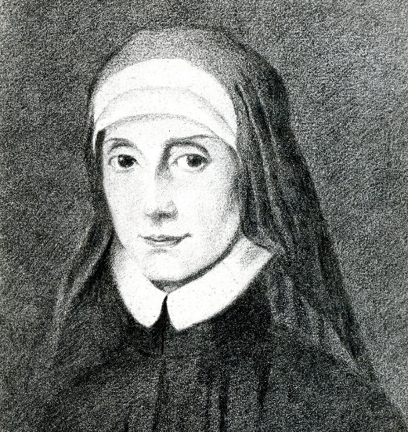
They continued to grow and there is now a global following of thousands of religious sisters and around 200 schools worldwide in Mary Ward’s name.
Pope John Paul II singled Mary Ward out as an "extraordinary Yorkshire woman and a pioneer" in 1982 and, in 2009, she was declared Venerable by Pope Benedict XVI.
Today, her followers and supporters are working on the cause to have her declared a Saint and a petition was launched in January.
Figure 3 Mary Ward, Illustration by Ellie Lewis
To find out more and sign the petition please visit: https://chng.it/PpF5pf8gCW
Find out more about the Extraordinary life of Mary Ward: www.youtube.com/watch?v=w99rpo8Vwb
How might our faith help us show courage, persistence, deep faith, cheerfulness and common sense in our lives?

- Return back over Ouse Bridge, bear right on Nessgate and cross the road junction with Coppergate onto Castlegate.

Esther Tuke (1727-1794)

Esther Tuke, a Quaker, lived with her husband above the family shop on Castlegate. She was a pioneer in mental health reform, education and greater equality for women. She founded the Quaker girls’ school in Castlegate which developed into The Mount School. As a preacher, she travelled across England and Scotland encouraging the young to be more generous and open minded. She led a campaign for women to play a more equal role in Quaker thought.
She and her daughter Ann were key figures in creating the climate that led local Quakers to found The Retreat in York, the first hospital in the world to create a pattern of humane treatment of the mentally ill.
She was renowned for her hospitality, humour and charm. Her home in Castlegate was a centre for overseas visitors and her religion, visitors said, ‘governed her steps, but was seldom the topic of her conversation’.

How can we be generous and open minded and how might we use hospitality and humour to share our faith?

- Further along Castlegate on the right hand side is Friargate where the Quaker Meeting House is located.

Mary Hughs (1886-1953)

In 1938 Mary Hughes, a York Quaker, co-founded the York Refugee Committee, one of a nationwide network of volunteers, who offered financial support to and found homes for Jews and political refugees escaping occupied Europe. Mary was Hospitality Secretary and worked closely with Dorothy Ditcham, the Secretary.
The Committee was very successful and by May 1939 there were 118 refugees living in York. Two employment bureaus were set up, along with sports and social clubs. Many of those who were settled in York during the war chose to stay after 1945, a lasting testimony to the work of Mary and the Refugee Committee.
To learn more visit www.herstoryyork.org.uk/mary-hughes-co-founder-york-refugee-committee/
In the 1970’s and 1980’s a number of Asian families expelled from Kenya and Uganda settled in York and in the 1990’s York provided accommodation for refugees from the Balkans.
In 2016 York was recognised as a City of Sanctuary and organisations like Refugee Action York and York City of Sanctuary work in partnership with other groups to welcome asylum seekers, refugees and migrants and celebrate the contribution of people seeking safety and resettlement in the UK.
How can we live lives, thankful for all that God has given us and extend hospitality and welcome to others seeking safety in our country?

- Walk through Coppergate Shopping Centre, turning right in front of the church onto Coppergate, walking towards M&S. Cross the large junction at the bottom of Parliament Street onto Pavement. The building which today houses Pizza Hut was where the Rowntree family had a shop.

Sarah Rowntree (1807-1888) 28 Pavement

Sarah, a Quaker, married Joseph Rowntree in 1832 and took up residence in their home on Pavement. She was involved in the affairs of the shop, helping with the accounts and advising her husband.
She was authorised to speak as a minister and she would always pray before speaking that her words would not be found dull and uninteresting. She also began to hold Bible classes for young women at the York Meeting in the hope that they might further their understanding of religion.
In addition to attending worship, she visited the poor, served on the managing committees of both Quaker schools and the York Penitentiary.
How can we ask God to help us share our faith effectively through our words and actions?

- Cross the road and walk past M&S, then turn left up The Shambles. Half way along on the left hand side is a shrine to Margaret of Clitherow.

Margaret Clitherow (1556-1586 ) ‘Pearl of York’

Margaret Clitherow lived with her husband, a butcher, above the shop on The Shambles.
As an adult she converted to Catholicism and, following the outlawing of Catholic religious ceremonies in 1581, she secretly hosted Catholic Masses and set up a hidden room in their home as a refuge for Catholic priests, a crime punishable by death.
Her trial was held at the Guildhall and in 1586 she was put to death on Ouse Bridge (a previous stop on our trail) for her refusal to renounce her faith.
How do we find the courage to stand up for our beliefs in the face of criticism?

- Walk back down The Shambles. Just before you reach the street, go through the stone arch on the left along the small snickleway to Whip-ma-wop-ma Gate, and continue straight ahead onto St Saviourgate and back to Central Methodist Church.
Fun fact: Whip-ma-whop-ma Gate is the shortest road in York.

Written by Angie Creswick for the Hilda’s Heirs event, 9th March 2024, revised March 2025.
With thanks to the following for their support and assistance with the research.
York Civic Trust yorkcivictrust.co.uk
Herstory York herstoryyork.org.uk
Streetlife York streetlifeyork.uk
Saved to Serve by E. Dorothy Graham
The Bar Convent barconvent.co.uk
Friargate Meeting House friargate.quakermeeting.org
York Methodist Circuit yorkmethodist.org.uk

