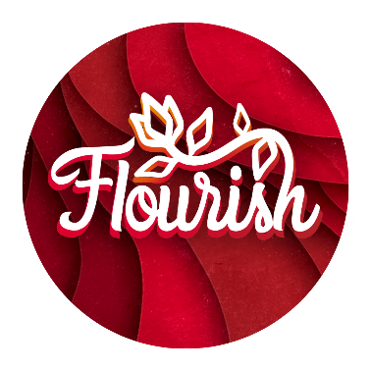
BOOKING FORM
FLOURISH : woven threads
Friday 13th to Sunday 15th February 2026 | University of York
This is a template form for local churches or circuits to use to collect Flourish ticket bookings to be inputted online through our ticket office: https://bit.ly/Flourish26

Note: Ticket prices are heavily subsidised by Yorkshire North & East Methodist District. Anyone for whom the cost is prohibitive should seek support from their church, circuit, or get in contact with the District (in that order). Tickets allow you to attend any day or the whole weekend of Flourish – however, please note some workshops and parts of the programme will have limited space; the purchase of a ticket will not guarantee entry to these, and you may be directed to an alternative session.
Please only buy tickets if you intend to come, as unfortunately no refunds are available.
Note: *cost doesn’t include online booking fee (calculated during checkout as a % of your order)
General Tickets
Ticket Type | Cost | Number of Tickets
Adult – Supporter  General Admission - plus help us make Flourish the best it can be for everyone! | £45.00*
Adult – Subsidised  Our subsidised price so ticket costs aren’t an obstacle. We want it to be affordable to everyone | £25.00*
Under 18 ticket  For children NOT accessing the youth programme | £10.00*
Under 5s  There is no specific provision for under 5s, however much of the weekend is family friendly for all ages, unless otherwise indicated on the programme | Free
Family Ticket (2 adults & up to 3 children)  Or 1 adult & up to 4 under 18s. General Admission to the weekend - this ticket does NOT include access to the children and youth stream. | £60.00*
Pitch in! (volunteer)  If you are interested in being a volunteer (multiple roles available), select this ticket! Volunteers for the CYF team should head to the CYF ticket page. You'll be contacted by the District Office when selecting this ticket. | Free
Support Flourish further  Consider giving an optional donation | Amount: £
Additional Products
Product Type | Cost | Number of Items
Flourish Hoodie  Navy Blue Hoodie with embroidered Flourish Logo and sponsorship printed on the back | £28.00
Hoodie Size Options  XS (Size Inch 34") | S (Size Inch 36") | M (Size Inch 40") | L (Size Inch 44") | XL (Size Inch 48") | 2XL (Size Inch 52") | 3XL (Size Inch 56") | 4XL (Size Inch 60") | 5XL (Size Inch 64") | Selection:
Youth Programme
For Children & Youth Stream tickets, please book here: https://bit.ly/FlourishCYF

YOUR DETAILS | Please complete the form below
LEAD PERSON
First Name | Last Name
Email Address
Phone Number
Where did you hear about Flourish?
Attended past events
Recommended or word of mouth
At Church
On Social Media
Leaflets or posters
Email
Other...
Which Methodist Circuit are you part of? (if applicable)
Are you interested in receiving Flourish update emails? | Yes / No
GENERAL TICKETS
Ticket 1: First Name | Last Name
Ticket 2: First Name | Last Name
Ticket 3: First Name | Last Name
Ticket 4: First Name | Last Name
Ticket 5: First Name | Last Name
Do any of the above have any accessibility requirements you would like us to be aware of?

Please submit these details through our ticket office: https://bit.ly/Flourish26


Find more information, key details, programme outline, and FAQs here:
www.yorkshirenemethodist.org/flourish26

