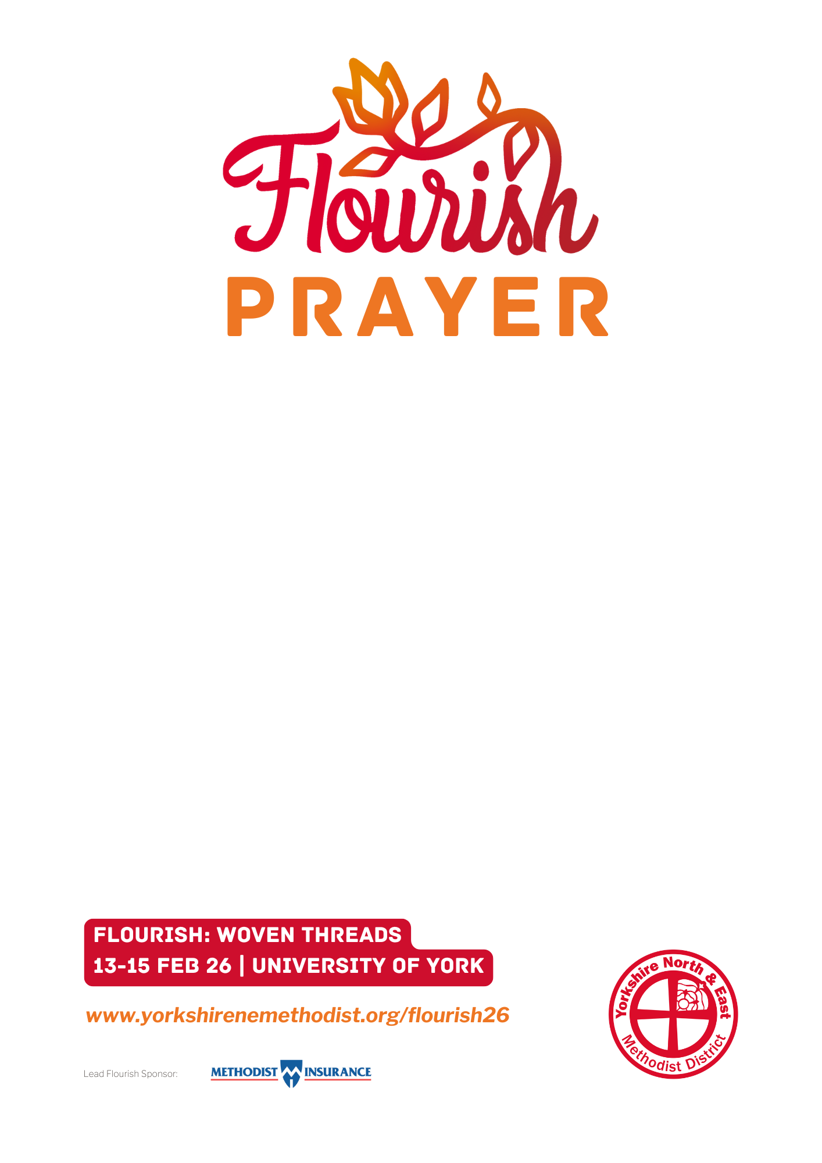
Creator of all, we pray with expectant hearts,
anticipating “Flourish”, our District Gathering,
and looking forward to all it offers.
We pray for the work of the planning team
as they attend to all the arrangements.
May all the speakers and contributors
be inspired in their preparation.
May we all be prepared by your Spirit as we gather:
ready to rediscover what it is to be
“Woven Threads” in God’s big tapestry.
May “Flourish” fulfil all our hopes, offering us fresh
inspiration, encouragement and motivation.
We pray, in the name of Christ.
Amen.

