Evolving Faith
Wilderness Book Club
Sundays @ 7pm online

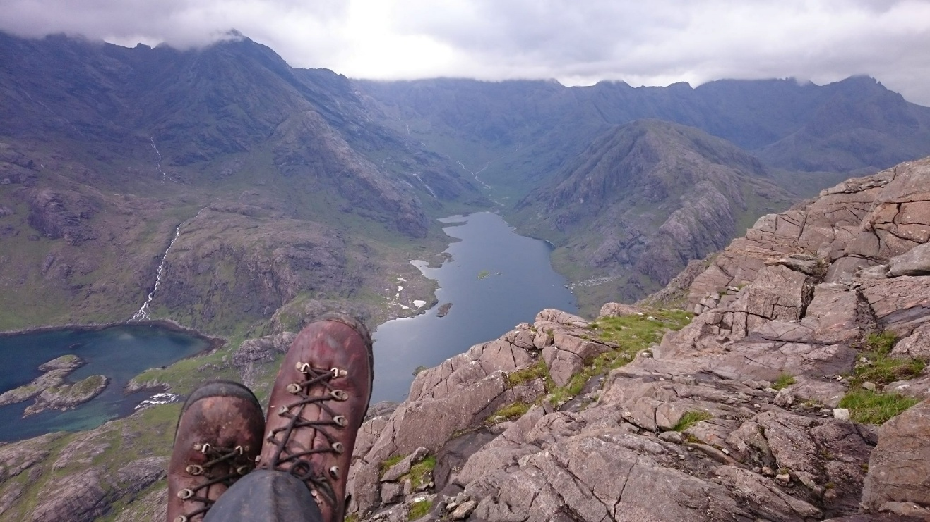

So much of the good stuff that happens for individuals and for Israel in scripture takes place in the wilderness, in in-between places; having left somewhere with relief or apprehension, by choice or having been forced, and facing unknowns ahead. This seems a powerful place for spiritual growth, borne out by many then and since who have found themselves somehow “in-between”.

Perhaps we never really arrive anywhere, but, like Israel, we can feel overly settled until the beliefs, patterns and practices of our old ways no longer seem to work.

How do we respond to falling into questions rather than answers, with limitation and mystery growing as certainty fades? “Evolving faith” is one way of describing the niggling or powerful feeling that things are no longer as they were for us, inside or out. We can walk away from faith or walk into the wilderness, hopefully with others.

Over the next year, on Sunday evenings, Rev Rory Dalgliesh will host on Zoom a discussion and exploration of what evolving faith might look and feel like, and what it asks of us in our following of Jesus, using some excellent books as a framework.

We begin 14th September with “Field Notes for the Wilderness” by Sarah Bessey.

If you want to find out more, please contact Rory Dalgliesh.

